Assignment – 9
Chabot application for any real-world scenario

Problem Statement:
A chatbot is an artificial intelligence program that simulates human conversation through voice or text interactions. In this assignment, we will develop a chatbot application for a Customer Support System in an online retail business. The chatbot will assist customers by answering queries, providing product information, handling complaints, and guiding them through the purchasing process.

Software used:
- Programming Language: Python
- Framework: Flask or Django (for web integration)
- NLP Library: NLTK or SpaCy (for natural language processing)
- Machine Learning: Scikit-learn or TensorFlow (for advanced query understanding)
- Database: SQLite or MongoDB (for storing user queries and responses)

Libraries and packages used:
- Flask: To create a web application for deploying the chatbot.
- NLTK/SpaCy: For natural language processing tasks such as tokenization, stemming, and entity recognition.
- ChatterBot: A Python library for creating chatbots that learn from conversations.
- Requests: For making API calls if needed.
- Pandas: For handling and analyzing customer data.

Theory:
The chatbot will use natural language processing (NLP) techniques to understand user inputs and generate relevant responses. It can be rule-based or machine learning-based, depending on the complexity of the interactions. Key components include:
- User Intent Recognition: Understanding what the user is asking for.
- Response Generation: Crafting appropriate responses based on the recognized intent.
- Context Management: Keeping track of ongoing conversations to provide relevant information

Methodology:
- Define User Requirements: Identify the common queries and tasks customers might have, such as product inquiries, order status checks, and return policies.
- Design Chatbot Flow: Outline the conversation flow and structure based on user intents and responses. This can be visualized using flowcharts.
- Implement Chatbot Logic:
- Use NLP techniques to process user inputs.
- Create a database of predefined responses for common questions.
- Implement machine learning models for intent classification.
- Deploy the Chatbot: Use a web framework (e.g., Flask) to create a web interface where users can interact with the chatbot.
- Testing and Iteration: Test the chatbot with real users, gather feedback, and refine the logic and responses based on user interactions.

Advantages:
- 24/7 Availability: The chatbot can assist customers anytime, improving user experience.
- Cost-Effective: Reduces the need for a large customer support team, saving costs on manpower.
- Scalability: Capable of handling multiple customer queries simultaneously without delay.
- Instant Responses: Provides quick answers to frequently asked questions, reducing wait times.

Limitations:
- Limited Understanding: Chatbots may struggle with complex queries that require human-like understanding and empathy.
- Maintenance: Requires continuous updates and training to improve accuracy and handle new types of queries.
- Frustration: Users may become frustrated if the chatbot fails to understand their requests or provides irrelevant answers.

Applications with example:
- Customer Support: Assisting customers with product inquiries, troubleshooting issues, and guiding them through purchase processes.
- E-commerce: Providing personalized recommendations based on user preferences and past purchases.
- Booking Systems: Assisting users with making reservations for hotels, flights, or events.
Example:
A customer asks the chatbot, "What are your return policies?" The chatbot recognizes the intent and responds with:
"Our return policy allows you to return items within 30 days of purchase. Please ensure that the items are in their original condition."

Working / Algorithm:
- Define User Intents and Responses: Create a set of intents that represent the different queries customers may have.
- Implement Natural Language Processing: Use NLTK or SpaCy for tokenization and intent recognition.
- Generate Responses Based on User Intent: Create a function that generates responses based on identified intents.
- Set Up a Simple Web Interface: Using Flask, create a web application where users can chat with the bot.
- Execute and Test the Application: Run the Flask application and test the chatbot using a REST client (like Postman) or through a simple web interface.

Diagram:

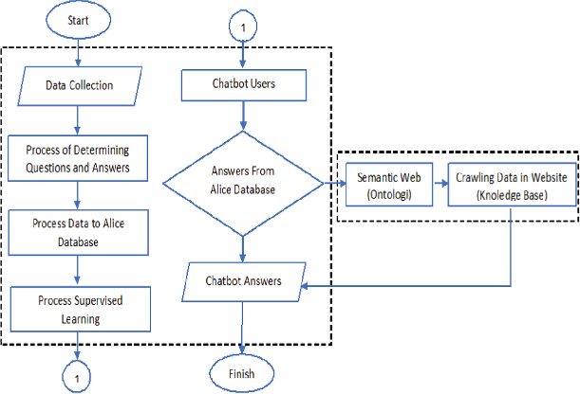

Conclusion:
The development of a chatbot application for a customer support system illustrates the effective use of artificial intelligence and natural language processing to enhance user experience in e-commerce. By providing quick and accurate responses to customer queries, the chatbot can significantly improve customer satisfaction while reducing operational costs for businesses. Continuous learning and improvement of the chatbot through user interactions and feedback will ensure its effectiveness in meeting customer needs over time.

